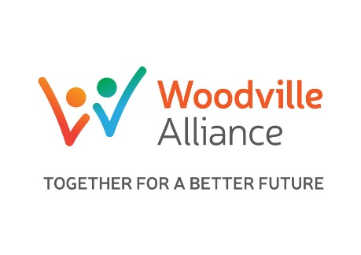
Case Management Referral
Please Note all files below are mandatory: We are unable to respond to a referral unless all information is provided
All fields marked * are mandatory

Child/Young Person’s Details

*Full Name

*Date of Birth |  |  | *Gender
*Address
*Suburb
*State |  |  | *Postcode

Cultural Identity (tick)
*Aboriginal |  | *Torres  Strait  Islander |  | *Other (specify

Family Member/s – main carer/s
*Name |  | *Contact Number
*Relationship to client
Name |  | *Contact Number
Relationship to client

*Is a language other than English spoken as a first language in  the home? (please circle) |  |  |  | Yes | No | Unsure
*Please identify first language
*If yes is an interpreting service required (please circle) | Yes | No | Unsure | *Who requires a translator?
*If yes which language

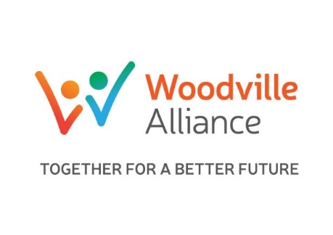
Further Child/young person details (living in the family who may require support)
Name | DOB/Age | Cultural Identity | School (if applicable)

Additional Agency involvement
*Are any other agencies working with the child/young person or their family (please circle)? This includes any referrals you have made to other agencies |  | Yes | No | Unsure
Name | Agency | Contact number

Pre-assessment details: The boxes below are intended to be used as prompts for identifying additional need. They are not prescriptive, rather their purpose is to look at the 6 main outcome areas for children and young people, and to consider whether needs are being met. If you are unsure, or don’t know information relating to the prompts, please state this providing an explanation for why this information is unknown. This will assist in directing further assessment

- Physical Health: Does the child or young person appear to be healthy?

This means babies children and young people are physically healthy, sexually healthy, living healthy lifestyles, and choosing not to take illegal drugs. Are the parents, carers and families able to promote healthy choices to their children?

- Mental Health
This means children and young people are mentally and emotionally healthy; confident, successfully dealing with life changes and challenges. If not provide details of difficulties experienced. Are the parents, carers and families able to promote resilience?

- Relationships
This means babies children and young people engaging in social and community activities, developing positive relationships, both within their family, wider family, peers and community: Are the parents, carers and families able to promote positive relationships? If not provide details of any difficulties experienced.

- Material wellbeing
This means young children are ready for school, school-age children attend and enjoy school, are achieving appropriate milestones at primary and high school and are achieving personal and social development through education. Are the parents, carers and families able to support learning? If not provide details of problems being experienced.

- Learning and Development
This means young children are ready for school, school-age children attend and enjoy school, are achieving standards at his means young children are ready for school, school-age children attend and enjoy school, are achieving appropriate milestones at primary and high school and are achieving personal and social development through education. Are the parents, carers and families able to support learning? If not provide details of problems being experienced.

- Safety
This means babies, children and young people are safe from maltreatment, neglect, violence and sexual exploitation, safe from accidental injury and death, safe from bullying and discrimination, safe from crime and anti-social behaviour in and out of school, and have security, stability and are cared for. Are parents, carers and families able to provide a safe home and stability? If not provide details of problems being experienced

Risks identified
*Any known risks related to particular individuals within the home e.g. substance misuse, criminality, history of violence etc. Please add details of any ROSH reports and/or FACS involvement (with dates)
*Details

*Referrer Name
*Agency
*Date |  | *Contact number
Signed by referrer
*Has the young person and/or their family provided consent to receive a service from Woodville Alliance? (Must circle Yes to submit) |  | Yes | Details:
 |  | No

Return completed referral to:

Woodville Alliance, Strong Minds
Email: strongminds@woodville.org.au

